Question 8 [6 Points]

Create a shell script bg_move.sh that accepts a directory path.
• Move each file in the directory into a subdirectory named backup/
• Perform each move operation in the background
• Display the PID of each background process
• Wait for all background processes to finishUse &, wait, $$, and $! variables.
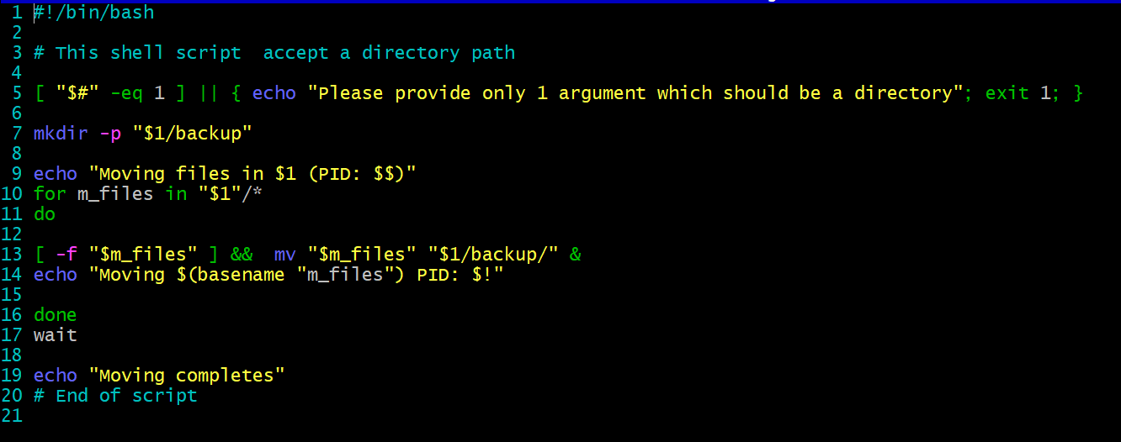
A directory with files
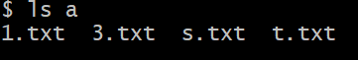
Moved files from a/ directory
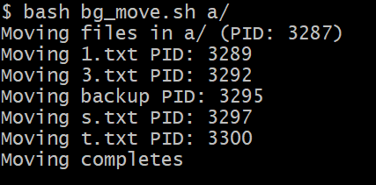


Explanation: Above scripts moves the files from provided directory to a backup directory and this is done in background using & command. In my script I have added some error checks and checks for files and move them to the backup directory. The PID no. is displayed using $! Command. At the end its prints the message moving completes and wait until all background process completes.

